1.71: a)
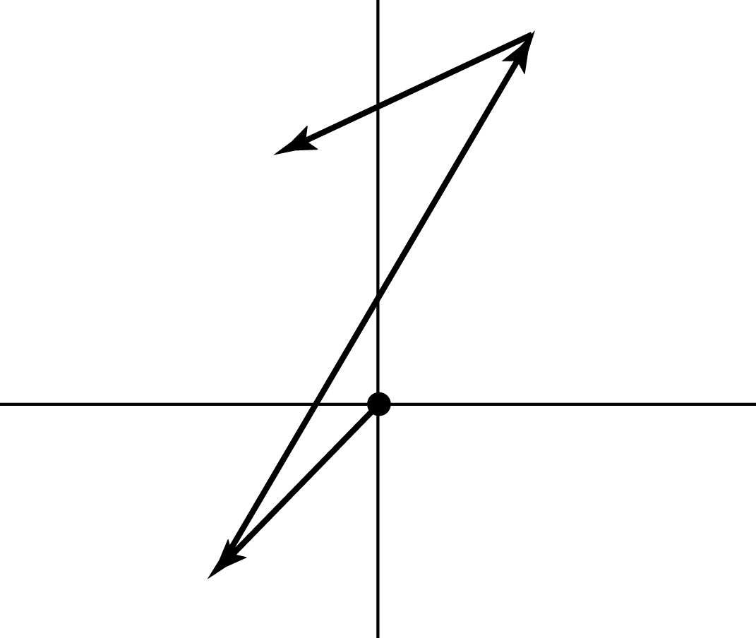

b) The net east displacement is and the net north displacement is
and so the distance traveled is 